# Tileset Textures

There are many textures that you can use for this, Tiled comes with some default map textures. You can find free assets on the web or in the Unity Asset store or use ones that you create yourself. A good place to look for free assets to use is [opengameart.org](http://opengameart.org/) and [Liberated Pixel Cup](http://lpc.opengameart.org/static/lpc-style-guide/assets.html)(part of Open Game Art). Kenney Vleugels has some free and paid assets found at <http://www.kenney.nl/>. Jason Perry has some good ones that are a part of his Time Fantasy Resource <http://www.timefantasy.net>, He has some free assets that are compatible with the paid assets. Another good paid asset is in the Unity Asset store called 3D Pixel Tiles [https://www.assetstore.unity3d.com/en/#!/content/14970](https://www.assetstore.unity3d.com/en/%23!/content/14970), for $12.50. The good thing about this asset is it also includes the full 2D Pixel Tileset asset. You can use the 2D tile set to create your map in Tiled and the 3D meshes to display a 3D map in Unity. Make sure that you follow the license that comes with the assets you are using. For the purpose of this tutorial I will be using the Tilesets that can be found at [opengameart.org](http://opengameart.org/) in particular the [Liberated Pixel Cup](http://lpc.opengameart.org/static/lpc-style-guide/assets.html) tiles. I have combined several of the assets into one big tile sheet.

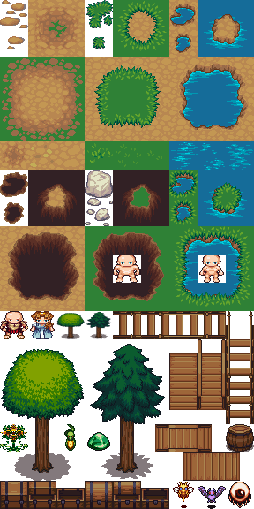

Copy the textures that you are going to use for your map into TileMapXML->Maps->Tilesets.

